**Central Tendency Placement Data**

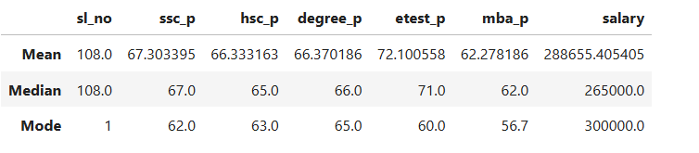

**Mean(Avg):"**

The average value “sslc pass” is 67.303395, **hsc_p=** **66.333163, degree_p=** **66.370186, etest_p=** **72.100558, mba_p=** **62.278186, salary=** **288655.405405** of the placement data, the highest average is entrance_test is 72.100558

**Median(Center value):**

The median values of the placement data is **ssc_p=** **67.0, hsc_p=** 65.0**, degree_p=** **66.0, etest_p=** 71.0**, mba_p=** 71.0**, salary=** **265000.0**

**Mode(Repeated value):**

The average values of the placement data is **ssc_p=** **62.0, hsc_p=** 63.0**, degree_p=** **65.0, etest_p=** 60.0**, mba_p=** 56.7**, salary=** **300000.0**